**Project Report**

**On**

**COVID19 Testing Management System**

Submitted in partial fulfillment of

DBMS Laboratory with Mini-Project (18CSL58)

Fifth Semester of the Degree of Bachelor of Engineering

Department of Computer Science and Engineering

Visvesvaraya Technological University, Belagavi

During the year from 2022-2023

Carried out by

**LAVANYA N [1SB20CS057] KUSHAL P REDDY [1SB20CS056]**

**INDU PATEL [1SB20CS042] JEEVAN GOWDA [1SB20CS044]**

Under the guidance of

Under the guidance of

Mr.Ramkumar

Assistant Professor Dept. of Computer Science and Engg.

Sri Sairam College of Engineering Sai Leo Nagar, Guddanahalli Post,

Anekal, Bengaluru – 562106

Under the guidance of

Mr.Ramkumar

Assistant Professor Dept. of Computer Science and Engg.

Sri Sairam College of Engineering Sai Leo Nagar, Guddanahalli Post,

Anekal, Bengaluru – 562106

 **Prof.A.SUGUNA**

Dept. of Computer Science and Engineering.

Sri Sairam College of Engineering Sai Leo Nagar, Guddanahalli Post

Anekal, Bengaluru – 562106



**Department of Computer Science and Engineering**

CERTIFICATE Certified that project work entitled “**COVID19 Testing Management System”**

is bonafide work carried out by

**LAVANYA N [1SB20CS057] KUSHAL P REDDY[1SB20CS056]**

**INDU PATEL [1SB20CS042] JEEVAN GOWDA[1SB20CS044]**

in partial fulfillment for the award of Bachelor of Engineering in **Computer Science and Engineering** of the Visvesvaraya Technological University, Belgaum during the year **2022-2023**. It is certified that all corrections/suggestions indicated for Internal Assessment have been incorporated in the report deposited in the department library. The Project report has been approved as it satisfies the academic requirements in respect of Project work prescribed for the Bachelor of Engineering Degree.

Signature of the Faculty Signature of the HOD

External Viva

Name of the Examiners:

1. ____________________________

2. __________________________

**DECLARATION**

We, the students of the fifth semester of Computer Science and Engineering, Sri Sairam College of Engineering, Anekal, declare that the work entitled “**COVID19 Testing Management System”**has been successfully completed under the guidance of **Prof.A.SUGUNA**, Assistant Professor, Computer Science and Engineering Department, Sri Sairam College of Engineering, Anekal. This dissertation work is submitted to Visvesvaraya Technological University in partial fulfillment of the requirements for the award of Degree of Bachelor of Engineering in Computer Science during the academic year 2022 - 2023. Further, the matter embodied in the project report has not been submitted previously by anyone for the award of any degree or diploma to any university.

Place:

Date:

Team members:

1. **LAVANYA N (1SB20CS057)**
2. **INDU PATEL (1SB20CS042)**
3. **KUSHAL P REDDY(1SB20CS056)**
4. **JEEVAN GOWDA (1SB20CS044)**

**ACKNOWLEDGEMENT**

It has been an honour and privilege to do my Seminar report on IFSC CODE FINDER SYSTEM.I take this opportunity to convey my sincere thanks and regards to Our Chairman and Chief Executive Officer **Sri Sai Prakash Leo Muthu**, and **Dr.Arun Kumar R**, Management Representative for offered me a chance to study in this institute and everyone who has helped me in successful completion of this seminar.

I take immense pleasure in expressing my sincere gratitude to **Dr.B.SHADAKSHARAPPA**, Principal, Sri Sairam College of Engineering, Bengaluru for giving me a constant encouragement and support to achieve my goal.

My sincere thanks to **Dr.SMITHA J A** Professor & Head, Dept. of Computer Science and Engineering for permitting us to undertake the Seminar work and for his invaluable guidance.

I express my deepest thanks to our Mini Project Guide **Prof A.SUGUNA** , Asst. Prof, Computer Science and Engineering for taking part in useful decision and guidance and arranging all facilities. I choose this moment to acknowledge her contribution grateful.

I perceive as this opportunity as a big milestone in my career development. I will strive to use gained skills and knowledge in the best possible way, and will continue to work on their improvement, in order to attain desired career objectives. Hope to continue cooperation with all of you in the future.

**CONTENTS**

1. Abstract
2. Introduction
3. Project Information
4. Purpose
5. Scope
6. Requirement Specification (Hardware Configuration, Software Requirement)
7. Analysis and Design (Use Case, ER and Class Diagram)
8. MySQL Data Tables (Structure of Each Table)
9. Implementation and System Testing
10. Evaluation (Project Output Screens)
11. Conclusion
12. References

**Abstract**

Nowadays, **COVID19 Testing Management System** is one of the most essential tools that are mostly used in Testing Lab; it is mostly used to manage COVID19 medical lab related activities.

In this project we tried to develop a computerized and web based COVID19 Testing management system. Our main intention is to allow this application to be used in most retailing COVID19 lab, where a small point of customization will be required to each COVID19 lab in the implementation period. This system is designed to overcome all challenges related to the management of diagnostic that were used to be handled locally and manually.

The system is an online COVID19 lab manager application that brings up various COVID19 test working online. Using this system, it will help us to records all transaction made at the daily tests; recognize all customers, employees, etc. It will manage all activities around the COVID19 lab that increases productivity and maximize profit, it will also minimizing the risk of getting loss because all transactions are recorded to the system.

**Introduction**

**INTRODUCTION TO SQL**

SQL which is an abbreviation for Structured Query Language is a language to request data from a database, to add, update, or remove data within a database, or to manipulate the metadata of the database.

Sometimes SQL is characterized as non-procedural because procedural languages generally require the details of the operations to be specified, such as opening and closing tables, loading and searching indexes, or flushing buffers and writing data to file systems. Therefore, SQL is designed at a higher conceptual level of operation than procedural languages.

Commonly used statements are grouped into the following categories

**Data Query Language (DQL)**

SELECT-Used to retrieve certain records from one or more tables.

**Data Manipulation Language (DML)**

INSERT - Used to create a record

UPDATE - Used to change certain records.

DELETE - Used to delete certain records.

**Data Definition Language (DDL)**

CREATE - Used to create a new table, a view of a table, or other object in database.

ALTER - Used to modify an existing database object, such as a table.

DROP - Used to delete an entire table, a view of a table or other object in the database.

**Data Control Language (DCL)**

GRANT - Used to give a privilege to someone

**OBJECTIVE OF THE PROJECT**

COVID19 Testing Management System is web based technology which brings up various diagnosis works online. Here patients are first allowed to register on the website and provide personal, test information. Once registered with their address and contact details, the patients may now see a variety of tests conducted by the lab. The patient will select the required test and book appointment after that lab center send a lab boy at registered address to collect a sample. After successful sample collection patient can track their test history using the name, order and registered mobile number. The system allows admin to attach a copy of the report into the system and automatically shown on user side so user can downloads report.

In COVID19 Testing Management System we use PHP and MySQL database. It has three modules i.e.

1. **Admin**
2. **User (Patient)**

**Admin Module**

Admin is the super user of the website who can manage everything on the website. Admin can log in through the login page

* **Dashboard:** In this section, the admin can see all detail in brief like the total, assigned and the sample collected and completed tests.
* **Phlebotomist:** In this section, the admin can manage Phlebotomist (add, update, delete).
* **Testing**: In this section, the admin can manage all the tests like assign the test to Phlebotomist and update the history.
* **Report:**In this section, the admin can generate two types of report. One is between dates reports and another one is by search. Admin can search the report by order number, name and mobile number.
* **Notification:** In this section, the admin will get a notification for every new test request (notification bell).
* Admin can also update his profile, change the password and recover the password.

**User (Patient) Module**

* User can visit the application through a URL.
* **Testing:** This section divided into two parts. One is for new user and another one is for registered user. New user (First-time user) needs to provide personal and testing Information. A registered user only needs to provide test information; their personal information will be fetched from the database.
* **Report:** In this section, Users can search their test report using order number, name and registered mobile number.
* **Dashboard:**In this section, the User can see the in which State of how many tests are done.

**Purpose**

The main purpose of COVID19 Testing management system to provide a platform where patients can book the test online and get their COVID19 test done at home. With the help of this project we are bringing the use of technology in the field of medical diagnosis where patients can avail all the diagnosis facilities at their door steps. Another purpose for developing this application is to generate the report automatically.

**Scope**

Today also we have to go to the COVID19 Test Lab center, wait in the queue to get our COVID19 test done. As Technology is growing rapidly we are also moving to a technical world where everything we want to be online. So with the help of this project we are bringing the use of technology in the field of medical diagnosis where patients can avail all the diagnosis facilities at their door steps. This project makes the diagnosis process easy and reduces the burden of patients. At a same time its help the diagnostic center to track all their patients details with their test reports. This access friendly software provides quick and effective services which helps the diagnostic center to increase their sales and profit.

**Advantages:**

* The system allows automate diagnosis system.
* Allows for faster service.
* Allows increased sales and profits for diagnostic labs.
* Easy, user friendly GUI.
* Validation of data will be ensure only accurate valid and complete data stored in the database.
* Easy retrieval or data will be made possible by finding techniques.
* Report generation will help made it easy to analyze the performance.

**Disadvantages:**

* It reduces employment as the human efforts are being automated by this system.

**Requirement Specification**

**Hardware Configuration:**

**Client Side:**

|  |  |
| --- | --- |
| **RAM RAMfgdfRA RAM** | 512 MB |
|  |  |
| **Hard disk** | 10 GB |
|  |  |
| **Processor** | 1.0 GHz |
|  |  |

**Server side:**

|  |  |
| --- | --- |
| **RAM** | **1 GB** |
| **Hard disk** | **20 GB** |
| **Processor** | **2.0 GHz** |

**Software Requirement:**

**Client Side:**

|  |  |
| --- | --- |
| **Web Browser** | Google Chrome or any compatible browser |
| **Operating System** | Windows or any equivalent OS |

**Server Side:**

|  |  |
| --- | --- |
| **Web Server** | APACHE |
| **Server side Language** | PHP5.6 or above version |
| **Database Server** | MYSQL |
| **Web Browser** | Google Chrome or any compatible browser |
| **Operating System** | Windows or any equivalent OS |

**APACHE**

The Apache HTTP Server Project is an effort to develop and maintain an open-source HTTP server for modern operating systems including UNIX and Windows. The goal of this project is to provide a secure, efficient and extensible server that provides HTTP services in sync with the current HTTP standards.

The Apache HTTP Server ("httpd") was launched in 1995 and it has been the most popular web server on the Internet since April 1996. It has celebrated its 20th birthday as a project in February 2015.

**PHP**

* PHP stands for PHP: Hypertext Preprocessor.
* PHP is a server-side scripting language, like ASP.
* PHP scripts are executed on the server.
* PHP supports many databases (MYSQL, Informix, Oracle, Sybase, Solid, Generic ODBC, etc.).
* PHP is an open source software.
* PHP is free to download and use.

**MYSQL**

* MYSQL is a database server
* MYSQL is ideal for both small and large applications
* MYSQL supports standard SQL
* MYSQL compiles on a number of platforms
* MYSQL is free to download and use
* How to access MySQL:

http://localhost/phpmyadmin

**Analysis and Design**

**Analysis:**

Today also we have to go to the diagnostic center, wait in the queue to get our COVID19 test done. As Technology is growing rapidly we are also moving to a technical world where everything we want to be online. So with the help of this project we are bringing the use of technology in the field of medical diagnosis where patients can avail all the diagnosis facilities at their door steps. This project makes the diagnosis process easy and reduces the burden of patients. At a same time its help the diagnostic center to track all their patients details with their test reports.

**Disadvantage of present system:**

* **Not user friendly:** The present system not user friendly because data is not stored in structure and proper format.
* **Manual Control:** All report calculation is done manually so there is a chance of error.
* **Lots of paper work:** Visitors maintain in the register so lots of paper require storing details.
* **Time consuming**

**Design Introduction:**

Design is the first step in the development phase for any techniques and principles for the purpose of defining a device, a process or system in sufficient detail to permit its physical realization. Once the software requirements have been analyzed and specified the software design involves three technical activities - design, coding, implementation and testing that are required to build and verify the software.

The design activities are of main importance in this phase, because in this activity, decisions ultimately affecting the success of the software implementation and its ease of maintenance are made. These decisions have the final bearing upon reliability and maintainability of the system. Design is the only way to accurately translate the customer’s requirements into finished software or a system.

Design is the place where quality is fostered in development. Software design is a process through which requirements are translated into a representation of software. Software design is conducted in two steps. Preliminary design is concerned with the transformation of requirements into data.

**UML Diagrams:**

Actor:  
 A coherent set of roles that users of use cases play when interacting with the use `cases.

Use case: A description of sequence of actions, including variants, that a system performs that yields an observable result of value of an actor.

UML stands for Unified Modeling Language. UML is a language for specifying, visualizing and documenting the system. This is the step while developing any product after analysis. The goal from this is to produce a model of the entities involved in the project which later need to be built. The representation of the entities that are to be used in the product being developed need to be designed.

**USECASE DIAGRAMS:**

Use case diagrams model behavior within a system and helps the developers understand of what the user require. The stick man represents what’s called an actor.

Use case diagram can be useful for getting an overall view of the system and clarifying that can do and more importantly what they can’t do.

Use case diagram consists of use cases and actors and shows the interaction between the use case and actors.

* The purpose is to show the interactions between the use case and actor.
* To represent the system requirements from user’s perspective.
* An actor could be the end-user of the system or an external system.

**USECASE DIAGRAM:** A Use case is a description of set of sequence of actions. Graphically it is rendered as an ellipse with solid line including only its name. Use case diagram is a behavioral diagram that shows a set of use cases and actors and their relationship. It is an association between the use cases and actors. An actor represents a real-world object. Primary Actor – Sender, Secondary Actor Receiver

**Use Case Diagrams:**

**Admin**

**User (Patient):**

**Class Diagram:**

A description of set of objects that share the same attributes operations, relationships, and semantics

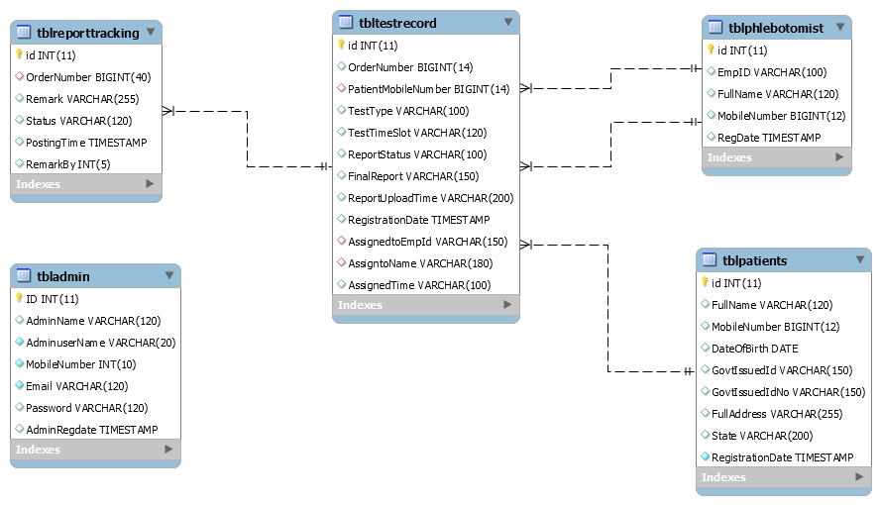

**ER Diagram:**

The Entity-Relationship (ER) model was originally proposed by Peter in 1976 [Chen76] as a way to unify the network and relational database views. Simply stated the ER model is a conceptual data model that views the real world as entities and relationships. A basic component of the model is the Entity-Relationship diagram which is used to visually represent data objects. Since Chen wrote his paper the model has been extended and today it is commonly used for database design for the database designer, the utility of the ER model is:

* It maps well to the relational model. The constructs used in the ER model can easily be transformed into relational tables.
* It is simple and easy to understand with a minimum of training. Therefore, the model can be used by the database designer to communicate the design to the end user.
* In addition, the model can be used as a design plan by the database developer to implement a data model in specific database management software.

**ER Notation:**

There is no standard for representing data objects in ER diagrams. Each modeling methodology uses its own notation. The original notation used by Chen is widely used in academics texts and journals but rarely seen in either CASE tools or publications by non-academics. Today, there are a number of notations used; among the more common are Bachman, crow's foot, and IDEFIX.

All notational styles represent entities as rectangular boxes and relationships as lines connecting boxes. Each style uses a special set of symbols to represent the cardinality of a connection. The notation used in this document is from Martin. The symbols used for the basic ER constructs are:

* **Entities** are represented by labeled rectangles. The label is the name of the entity. Entity names should be singular nouns.
* **Relationships** are represented by a solid line connecting two entities. The name of the relationship is written above the line. Relationship names should be verbs
* **Attributes**, when included, are listed inside the entity rectangle. Attributes which are identifiers are underlined. Attribute names should be singular nouns.

.

**ER Diagram:**

.

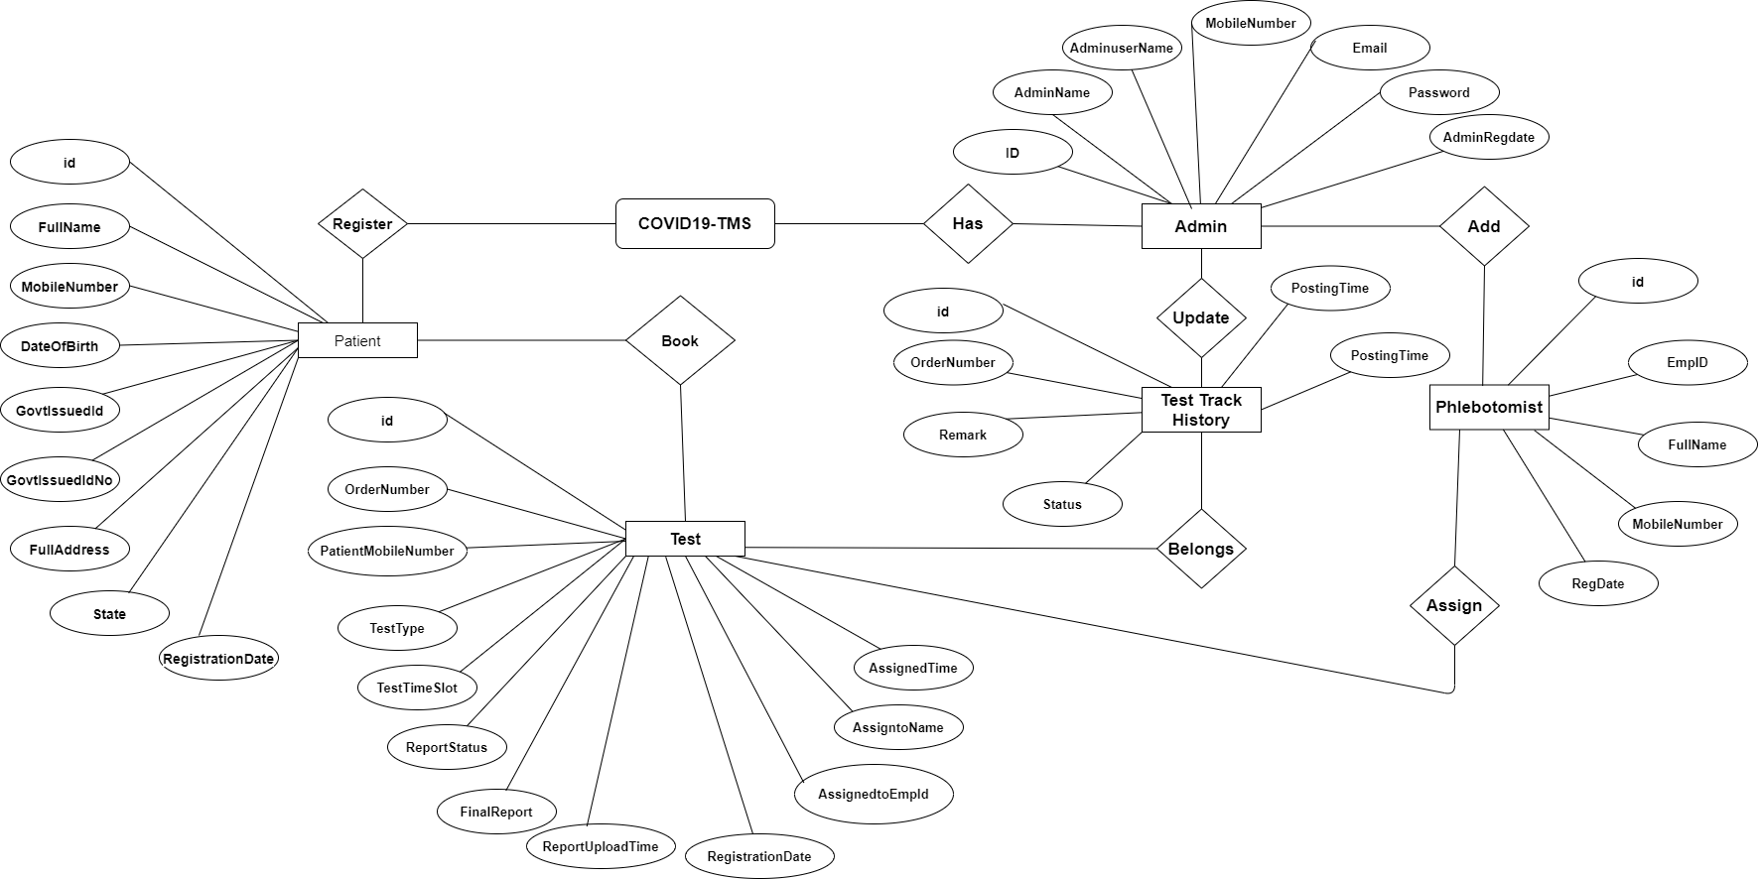

**MySQL Data Tables**

**Admin Table:**(Table name is tbladmin)

This store admin personal and login details.

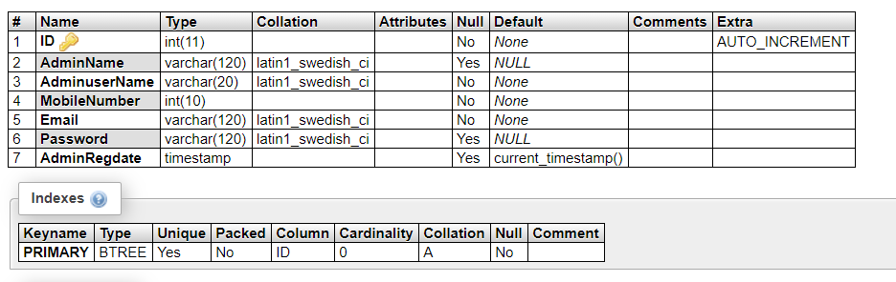

**tblpatients**

This table store the data of patient personal Information.

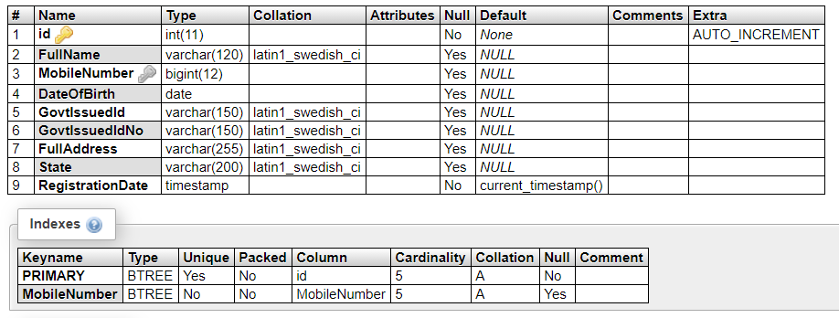

**tbltestrecord**

This table stores the patient test record details

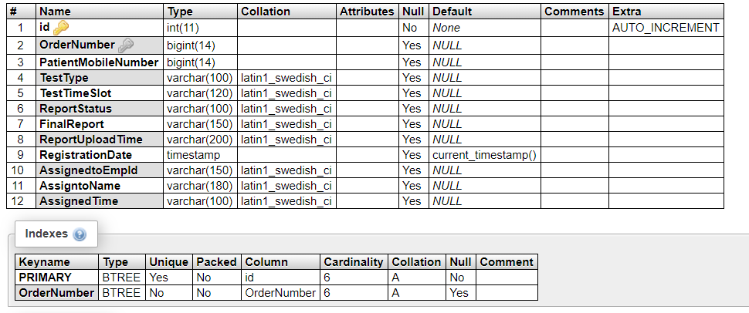

**tblreporttracking**

This table stores the tracking details of tests.

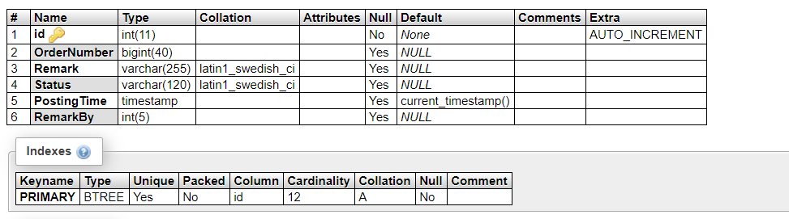

**tblphlebotomist**

This table stores the phlebotomist information.

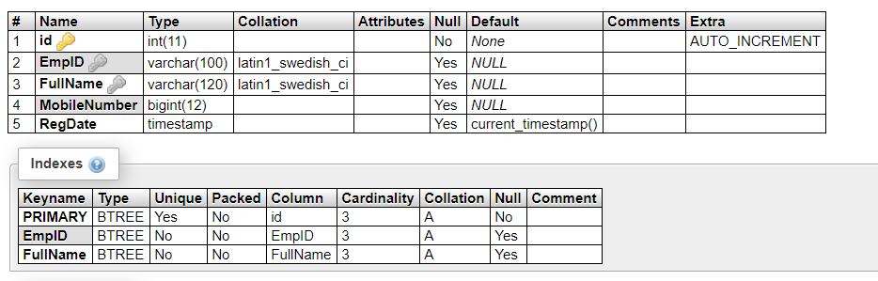

**Implementation and System Testing**

After all phase have been perfectly done, the system will be implemented to the server and the system can be used.

**System Testing**

The goal of the system testing process was to determine all faults in our project .The program was subjected to a set of test inputs and many explanations were made and based on these explanations it will be decided whether the program behaves as expected or not. Our Project went through two levels of testing

1. Unit testing

2. Integration testing

**UNIT TESTING**

Unit testing is commenced when a unit has been created and effectively reviewed .In order to test a single module we need to provide a complete environment i.e. besides the section we would require

* The procedures belonging to other units that the unit under test calls
* Non local data structures that module accesses
* A procedure to call the functions of the unit under test with appropriate parameters

**1. Test for the admin module**

* **Testing admin login form-**This form is used for log in of administrator of the system. In this form we enter the username and password if both are correct administration page will open otherwise if any of data is wrong it will get redirected back to the login page and again ask the details.
* **Report Generation:** admin can generate report from the main database.

**INTEGRATION TESTING**

In the Integration testing we test various combination of the project module by providing the input.

The primary objective is to test the module interfaces in order to confirm that no errors are occurring when one module invokes the other module.

**SOURCE CODE:**

**INDEX:**

**<!DOCTYPE html>**

**<html lang="en">**

**<head>**

**<meta charset="utf-8">**

**<meta name="viewport" content="width=device-width, initial-scale=1, shrink-to- fit=no">**

**<meta name="description" content="">**

**<meta name="author" content="">**

**<title>Covid-19 Testing Management System</title>**

**<!-- Bootstrap core CSS -->**

**<link href="vendor/bootstrap/css/bootstrap.min.css" rel="stylesheet">**

**<!-- Custom styles for this template -->**

**<link href="css/scrolling-nav.css" rel="stylesheet">**

**</head>**

**<body id="page-top">**

**<!-- Navigation -->**

**<nav class="navbar navbar-expand-lg navbar-dark bg-dark fixed-top" id="mainNav">**

**<div class="container">**

**<a class="navbar-brand js-scroll-trigger" href="#page-top">Covid19-TMS</a>**

**<button class="navbar-toggler" type="button" data-toggle="collapse" data-target="#navbarResponsive" aria-controls="navbarResponsive" aria-expanded="false" aria-label="Toggle navigation">**

**<span class="navbar-toggler-icon"></span>**

**</li>**

**<li class="nav-item active">**

**<a class="nav-link js-scroll-trigger" href="login.php">Admin</a>**

**</li>**

**</ul>**

**</div>**

**</div>**

**</nav>**

**<header class="bg-primary text-white">**

**<div class="container text-center">**

**<h1>COVID19-TMS</h1>**

**<p class="lead">COVID19 - Testing Management System</p>**

**</div>**

**</header>**

**<section id="about">**

**<div class="container">**

**<div class="row">**

**<div class="col-lg-8 mx-auto">**

**<h2>About this page</h2>**

**<p class="lead">Coronavirus disease (COVID-19) is an infectious disease caused by a newly discovered coronavirus. Most people infected with the COVID-19, virus will experience mild to moderate, respiratory illness & recover without requiring special treatment. Older people and those with underlying medical problem like cardiovascular disease.</p>**

**<p class="lead">The COVID-19 virus spread primarily through droplet of saliva or discharge from the nose when an infected person coughs or sneezes so it’s important that you also practice respiratory etiquette.</p>**

**</div>**

**</div>**

**</div>**

**</section>**

**<section id="services" class="bg-light">**

**<div class="container">**

**<div class="row">**

**<div class="col-lg-8 mx-auto">**

**<h2>Covid-19 Symptoms</h2>**

**<hr />**

**<p><strong>Hight Fever 2-14 days!</strong><br />**

**Reported illnesses have ranged from mild symptoms to severe illness and death</p>**

**<hr />**

**<p><strong>Dry Cough 2-14 days!</strong><br />**

**Reported illnesses have ranged from mild symptoms to severe illness and death</p**

**<footer class="py-5 bg-dark">**

**<div class="container">**

**<p class="m-0 text-center text-white">Copyright &copy; Your Website 2020</p>**

**</div>**

**<!-- /.container -->**

**</footer>**

**<!-- Bootstrap core JavaScript -->**

**<script src="vendor/jquery/jquery.min.js"></script>**

**<script src="vendor/bootstrap/js/bootstrap.bundle.min.js"></script>**

**<!-- Plugin JavaScript -->**

**<script src="vendor/jquery-easing/jquery.easing.min.js"></script>**

**<!-- Custom JavaScript for this theme -->**

**<script src="js/scrolling-nav.js"></script>**

**</body>**

**</html>**

**LOGIN PAGE:**

**<?php**

**session_start();**

**include('includes/config.php');**

**if(isset($_POST['login']))**

**{**

**$uname=$_POST['username'];**

**$Password=md5($_POST['inputpwd']);**

**$query=mysqli_query($con,"select ID from tbladmin where AdminuserName='$uname' && Password='$Password' ");**

**$ret=mysqli_fetch_array($query);**

**if($ret>0){**

**$_SESSION['aid']=$ret['ID'];**

**header('location:dashboard.php');**

**}**

**else{**

**echo "<script>alert('Invalid Details.');</script>";**

**}**

**}**

**?>**

**<!DOCTYPE html>**

**<html lang="en">**

**<head> <meta charset="utf-8">**

**<meta http-equiv="X-UA-Compatible" content="IE=edge">**

**<meta name="viewport" content="width=device-width, initial-scale=1, shrink-to-fit=no">**

**<meta name="description" content="">**

**<meta name="author" content="">**

**<title>Covid 19 Testing Management System | Admin Login</title>**

**<!-- Custom fonts for this template-->**

**<link href="vendor/fontawesome-free/css/all.min.css" rel="stylesheet" type="text/css">**

**<link**

**href="https://fonts.googleapis.com/css?family=Nunito:200,200i,300,300i,400,400i,600,600i,700,700i,800,800i,900,900i"**

**rel="stylesheet">**

**<!-- Custom styles for this template-->**

**<link href="css/sb-admin-2.min.css" rel="stylesheet">**

**</head>**

**<body class="bg-gradient-primary">**

**<div class="container">**

**<!-- Outer Row -->**

**<div class="row justify-content-center">**

**<div class="col-xl-10 col-lg-12 col-md-9">**

**<h3 align="center" style="margin-top:4%;color:#fff">Covid Testing Management System</h3>**

**<div class="card o-hidden border-0 shadow-lg my-5">**

**<div class="card-body p-0">**

**<!-- Nested Row within Card Body -->**

**<form name="login" method="post">**

**<div class="row">**

**<div class="col-lg-6 d-none d-lg-block bg-login-image"></div>**

**<input type="password" class="form-control" name="inputpwd"**

**id="inputpwd" placeholder="Password">**

**</div>**

**<input type="submit" name="login" class="btn btn-primary btn-user btn-block" value="login">**

**</form>**

**<hr>**

**<div class="text-center">**

**<a class="small" href="password-recovery.php" style="font-weight:bold">Forgot Password?</a>**

**</div><div class="text-center">**

**<a class="small" href="index.php" style="font-weight:bold;"><i class="fa fa-home" aria-hidden="true"></i> Home Page</a>**

**</div>**

**</div> </div>**

**</div></form>**

**</div>**

**</div>**

**</div>**

**</div>**

**</div>**

**<!-- Bootstrap core JavaScript-->**

**<script src="vendor/jquery/jquery.min.js"></script>**

**<script src="vendor/bootstrap/js/bootstrap.bundle.min.js"></script>**

**<!-- Core plugin JavaScript-->**

**<script src="vendor/jquery-easing/jquery.easing.min.js"></script>**

**<!-- Custom scripts for all pages-->**

**<script src="js/sb-admin-2.min.js"></script>**

**</body>**

**</html>**

**LOGOUT PAGE:**

**<?php**

**session_start();**

**session_unset();**

**session_destroy();header('location:index.php'); ?>**

**PASSWORD-RECOVERY:**

<?php

session_start();

include('includes/config.php');

if(isset($_POST['submit']))

{

$contactno=$_POST['contactno'];

$username=$_POST['username'];

$password=md5($_POST['newpassword']);

$query=mysqli_query($con,"select ID from tbladmin where AdminuserName='$username' and MobileNumber='$contactno' ");

$ret=mysqli_num_rows($query);

if($ret>0){

$query1=mysqli_query($con,"update tbladmin set Password='$password' where AdminuserName='$username' && MobileNumber='$contactno' ");

if($query1)

{

echo "<script>alert('Password successfully changed');</script>";

echo "<script>window.location.href='login.php'</script>";

}

}

else{

echo "<script>alert('Invalid Details. Please try again.');</script>"; }

}

?>

**PATIENT-REPORT-DETAILS PAGE:**

**<?php session_start();**

**//DB conncetion**

**include_once('includes/config.php');**

**error_reporting(0);**

**?>**

**<!DOCTYPE html>**

**<html lang="en">**

**<head> <meta charset="utf-8">**

**<meta http-equiv="X-UA-Compatible" content="IE=edge">**

**<meta name="viewport" content="width=device-width, initial-scale=1, shrink-to-fit=no">**

**<meta name="description" content="">**

**<meta name="author" content="">**

**<title>Covid-19 Testing Management System | Add Phlebotomist</title>**

**<!-- Custom fonts for this template-->**

**<link href="vendor/fontawesome-free/css/all.min.css" rel="stylesheet" type="text/css">**

**<link**

**href="https://fonts.googleapis.com/css?family=Nunito:200,200i,300,300i,400,400i,600,600i,700,700i,800,800i,900,900i"**

**rel="stylesheet">**

**<!-- Custom styles for this template-->**

**<link href="css/sb-admin-2.min.css" rel="stylesheet">**

**<style type="text/css">**

**label{**

**font-size:16px;**

**font-weight:bold;**

**color:#000;**

**}</style></head>**

**<body id="page-top">**

**<!-- Page Wrapper -->**

**<div id="wrapper">**

**<?php include_once('includes/sidebar.php');?>**

**<!-- Content Wrapper -->**

**<div id="content-wrapper" class="d-flex flex-column">**

**<!-- Main Content -->**

**<div id="content"><!-- Topbar -->**

**<?php include_once('includes/topbar.php');?>**

**<!-- End of Topbar -->**

**<!-- Begin Page Content -->**

**</tr> <tr>**

**<th>Mobile Number</th>**

**<td><?php echo $row['MobileNumber'];?></td>**

**</tr> <tr>**

**<th>DOB (Date of Birth)</th>**

**<td><?php echo $row['DateOfBirth'];?></td>**

**</tr> <tr>**

**<th>Govt Issued Id</th>**

**<td><?php echo $row['GovtIssuedId'];?></td>**

**</tr>**

**<tr>**

**<th>Govt Issued Id No</th>**

**<td><?php echo $row['GovtIssuedIdNo'];?></td>**

**</tr>**

**<tr>**

**<th>Full Address</th>**

**<td><?php echo $row['FullAddress'];?></td>**

**</tr>**

**<tr>**

**<th>State</th>**

**<td><?php echo $row['State'];?></td>**

**</tr>**

**<tr>**

**<th>Profile Reg Date</th>**

**<td><?php echo $row['RegistrationDate'];?></td>**

**<?php if($row['AssignedtoEmpId']!=''):?>**

**<tr>**

**<th>Assign To</th>**

**<td><?php echo $row['AssigntoName'];?>-(<?php echo $row['AssignedtoEmpId'];?>)</td>**

**</tr>**

**<!-- Test Tracking History --->**

**<?php**

**$orderid=intval($_GET['oid']);**

**$ret=mysqli_query($con,"select * from tblreporttracking**

**join tbladmin on tbladmin.ID=tblreporttracking.RemarkBy**

**where tblreporttracking.OrderNumber='$orderid'");**

**$num=mysqli_num_rows($ret);**

**?>**

**<div class="row">**

**<div class="col-lg-12">**

**<!-- Basic Card Example -->**

**<div class="card shadow mb-4">**

**<div class="card-header py-3">**

**<h6 class="m-0 font-weight-bold text-primary" align="center">Test Tracking History</h6>**

**</div>**

**<div class="card-body">**

**<?php if($num>0){**

**?>**

**<table class="table table-bordered" width="100%" cellspacing="0">**

**<tr>**

**<th>Remark</th>**

**<th>Status</th>**

**<th>Remark Date</th>**

**<th>Remark By</th>**

**<?php while($result=mysqli_fetch_array($ret)){?>**

**</tr>**

**<tr>**

**<td><?php echo $result['Remark'];?></td>**

**<td><?php echo $result['Status'];?></td>**

**<td><?php echo $result['PostingTime'];?></td>**

**<td><?php echo $result['AdminName'];?></td>**

**</tr>**

**<?php } // End while loop?>**

**</table>**

**<?php**

**//end if**

**} else { ?>**

**<h4 align="center" style="color:red"> No Tracking history found </h4>**

**<?php } ?>**

**<script src="vendor/jquery/jquery.min.js"></script>**

**<script src="vendor/bootstrap/js/bootstrap.bundle.min.js"></script>**

**<!-- Core plugin JavaScript-->**

**<script src="vendor/jquery-easing/jquery.easing.min.js"></script><!-- Custom scripts for all pages-->**

**<script src="js/sb-admin-2.min.js"></script>**

**<script type="text/javascript">**

**//For report file**

**$('#reportfile').hide();**

**$(document).ready(function(){**

**$('#status').change(function(){**

**if($('#status').val()=='Delivered')**

**{**

**$('#reportfile').show();**

**jQuery("#report").prop('required',true);**

**}**

**else{**

**$('#reportfile').hide();**

**}**

**})})**

**</script>**

**</body>**

**</html>**

**PATIENT-SEARCH-REPORT:**

**<?php session_start();**

**//DB conncetion**

**include_once('includes/config.php');**

**error_reporting(0);**

**?>**

**<!DOCTYPE html>**

**<html lang="en">**

**<head>**

**<meta charset="utf-8">**

**<meta http-equiv="X-UA-Compatible" content="IE=edge">**

**<meta name="viewport" content="width=device-width, initial-scale=1, shrink-to-fit=no">**

**<meta name="description" content="">**

**<meta name="author" content="">**

**<title>Covid-19 TMS | Search Report</title>**

**<!-- Custom fonts for this template-->**

**<link href="vendor/fontawesome-free/css/all.min.css" rel="stylesheet" type="text/css">**

**<link**

**href="https://fonts.googleapis.com/css?family=Nunito:200,200i,300,300i,400,400i,600,600i,700,700i,800,800i,900,900i"**

**<div id="content">**

**<!-- Topbar -->**

**<?php include_once('includes/topbar.php');?>**

**<!-- End of Topbar -->**

**<!-- Begin Page Content -->**

**<div class="container-fluid">**

**<!-- Page Heading -->**

**<h1 class="h3 mb-4 text-gray-800">Search Report</h1>**

**<form method="post" action="patient-report.php">**

**<div class="row">**

**<div class="col-lg-6">**

**<!-- Basic Card Example -->**

**<div class="card shadow mb-4">**

**<div class="card-body">**

**<div class="form-group">**

**<label>Search By Patient Name or Mobile Number or Order Number</label>**

**</script>**

**</body>**

**</html>**

**SAMPLESENT-LAB-TEST PAGE:**

**<?php session_start();**

**//DB conncetion**

**include_once('includes/config.php');**

**//validating Session**

**if (strlen($_SESSION['aid']==0)) {**

**header('location:logout.php');**

**} else{**

**?>**

**<!DOCTYPE html>**

**<html lang="en">**

**<head>**

**<meta charset="utf-8">**

**<meta http-equiv="X-UA-Compatible" content="IE=edge">**

**<meta name="viewport" content="width=device-width, initial-scale=1, shrink-to-fit=no">**

**<meta name="description" content="">**

**<meta name="author" content="">**

**<title>Covid-Tms | Sample Sent to lab</title>**

**<!-- Custom fonts for this template -->**

**<link href="vendor/fontawesome-free/css/all.min.css" rel="stylesheet" type="text/css">**

**<link**

**href="https://fonts.googleapis.com/css?family=Nunito:200,200i,300,300i,400,400i,600,600i,700,700i,800,800i,900,900i"**

**rel="stylesheet">**

**<!-- Custom styles for this template -->**

**<link href="css/sb-admin-2.min.css" rel="stylesheet">**

**<!-- Custom styles for this page -->**

**<link href="vendor/datatables/dataTables.bootstrap4.min.css" rel="stylesheet">**

**</head>**

**<body id="page-top">**

**<!-- Page Wrapper --><div id="wrapper"> <!-- Sidebar -->**

**<?php include_once('includes/sidebar.php');?>**

**<!-- End of Sidebar -->**

**<!-- Content Wrapper -->**

**<div id="content-wrapper" class="d-flex flex-column"><!-- Main Content -->**

**<div id="content">**

**<!-- Topbar -->**

**<?php include_once('includes/topbar.php');?>**

**<!-- End of Topbar -->**

**<!-- Begin Page Content -->**

**<div class="container-fluid">**

**<!-- Page Heading -->**

**<h1 class="h3 mb-2 text-gray-800">Sample Sent to lab</h1>**

**<!-- DataTales Example -->**

**<div class="card shadow mb-4">**

**<div class="card-header py-3">**

**<h6 class="m-0 font-weight-bold text-primary">Sample Sent to lab</h6>**

**</div>**

**<div class="card-body">**

**<div class="table-responsive">**

**<form name="assignto" method="post">**

**<table class="table table-bordered" id="dataTable" width="100%" cellspacing="0">**

**<thead>**

**<tr>**

**<th>Sno.</th>**

**<th>Order No.</th>**

**<th>Patient Name</th>**

**<th>Mobile No.</th>**

**<th>Test Type</th>**

**<th>Time Slot</th>**

**<th>Reg. Date</th>**

**<th>Action</th>**

**</tr>**

**</thead>**

**<tfoot>**

**<tr>**

**<th>Sno.</th>**

**<th>Order No.</th>**

**<th>Patient Name</th>**

**<th>Mobile No.</th>**

**<th>Test Type</th>**

**<th>Time Slot</th>**

**<th>Reg. Date</th>**

**<th>Action</th>**

**</tr>**

**</tfoot>**

**<tbody>**

**<?php $query=mysqli_query($con,"select tbltestrecord.OrderNumber,tblpatients.FullName,tblpatients.MobileNumber,tbltestrecord.TestType,tbltestrecord.TestTimeSlot,tbltestrecord.RegistrationDate,tbltestrecord.id as testid from tbltestrecord**

**join tblpatients on tblpatients.MobileNumber=tbltestrecord.PatientMobileNumber**

**where ReportStatus='Sent to Lab'**

**");**

**$cnt=1;**

**while($row=mysqli_fetch_array($query)){**

**?**

**<tr>**

**<td><?php echo $cnt;?></td>**

**<td><?php echo $row['OrderNumber'];?></td>**

**<td><?php echo $row['FullName'];?></td>**

**<td><?php echo $row['MobileNumber'];?></td>**

**<td><?php echo $row['TestType'];?></td>**

**<td><?php echo $row['TestTimeSlot'];?></td>**

**<td><?php echo $row['RegistrationDate'];?></td>**

**<td>**

**<a href="test-details.php?tid=<?php echo $row['testid'];?>&&oid=<?php echo $row['OrderNumber'];?>" class="btn btn-info btn-sm">View Details</a>**

**</td>**

**<?php $cnt++;} ?>**

**<?php include_once('includes/footer2.php');?>**

**<!-- Bootstrap core JavaScript-->**

**<script src="vendor/jquery/jquery.min.js"></script>**

**<script src="vendor/bootstrap/js/bootstrap.bundle.min.js"></script>**

**<!-- Core plugin JavaScript--><script src="vendor/jquery-easing/jquery.easing.min.js"></script> <!-- Custom scripts for all pages-->**

**<script src="js/sb-admin-2.min.js"></script>**

**<!-- Page level plugins -->**

**<script src="vendor/datatables/jquery.dataTables.min.js"></script>**

**<script src="vendor/datatables/dataTables.bootstrap4.min.js"></script>**

**<!-- Page level custom scripts -->**

**<script src="js/demo/datatables-demo.js"></script>**

**</body></html><?php } ?>**

**Evaluation**

**Project URL: http://localhost/cvovid19-tms**

**Home Page**

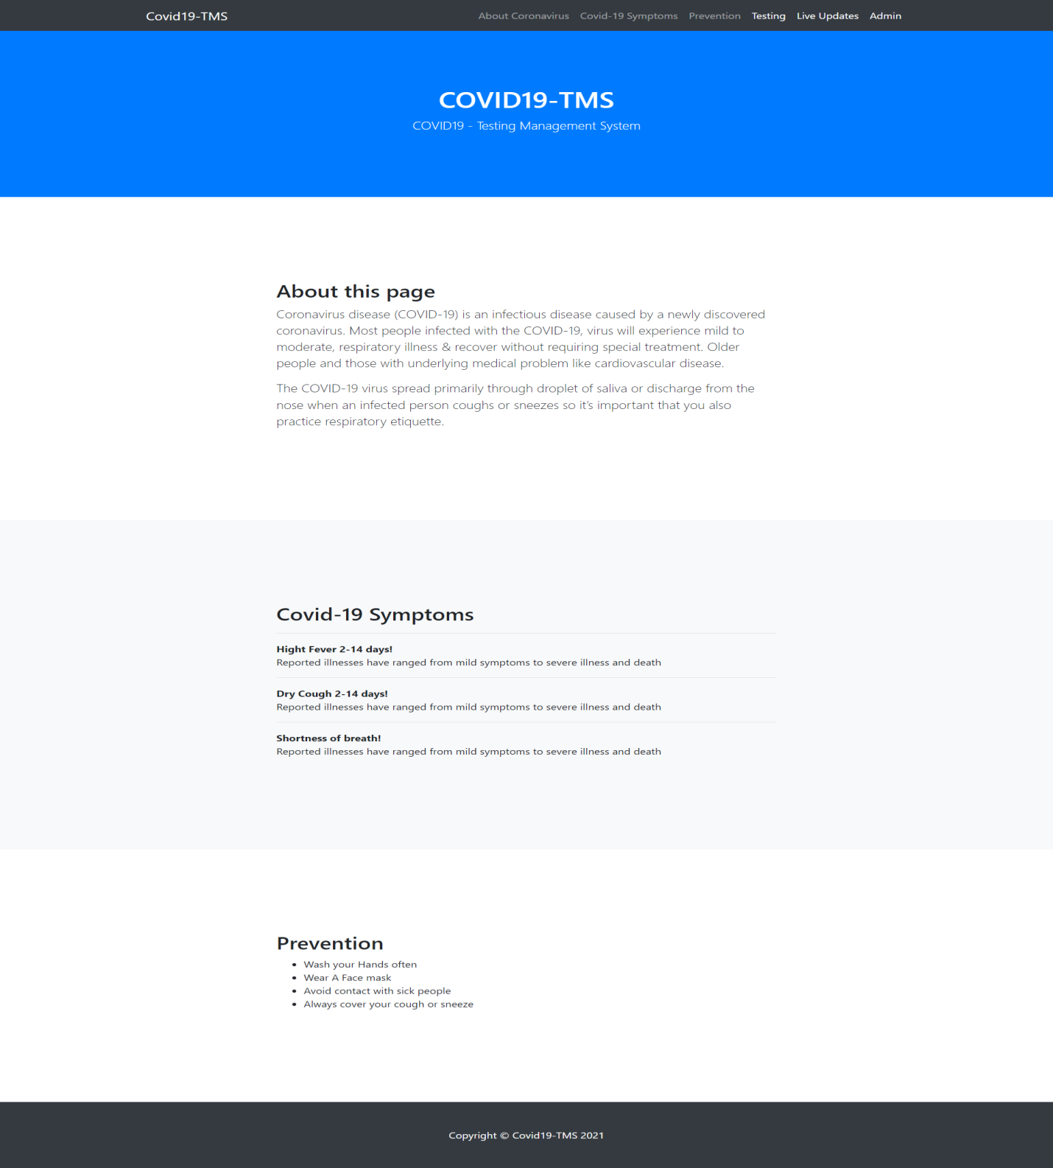

**New User (Patient) Test Booking**

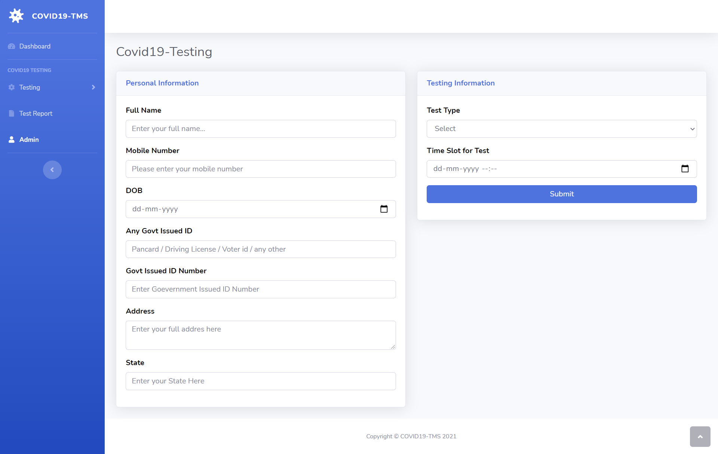

**Already Registered User (Patient) Test Booking**

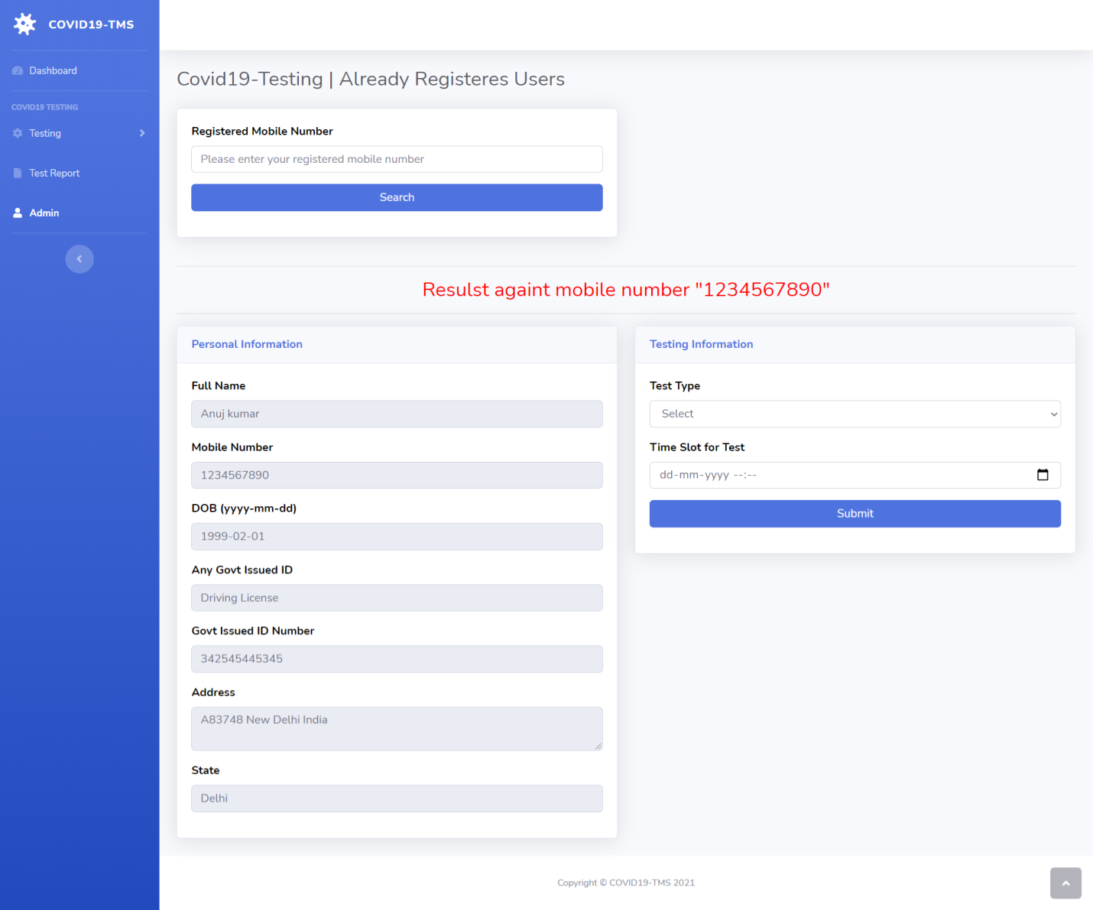

**User (Patient) Test Details**

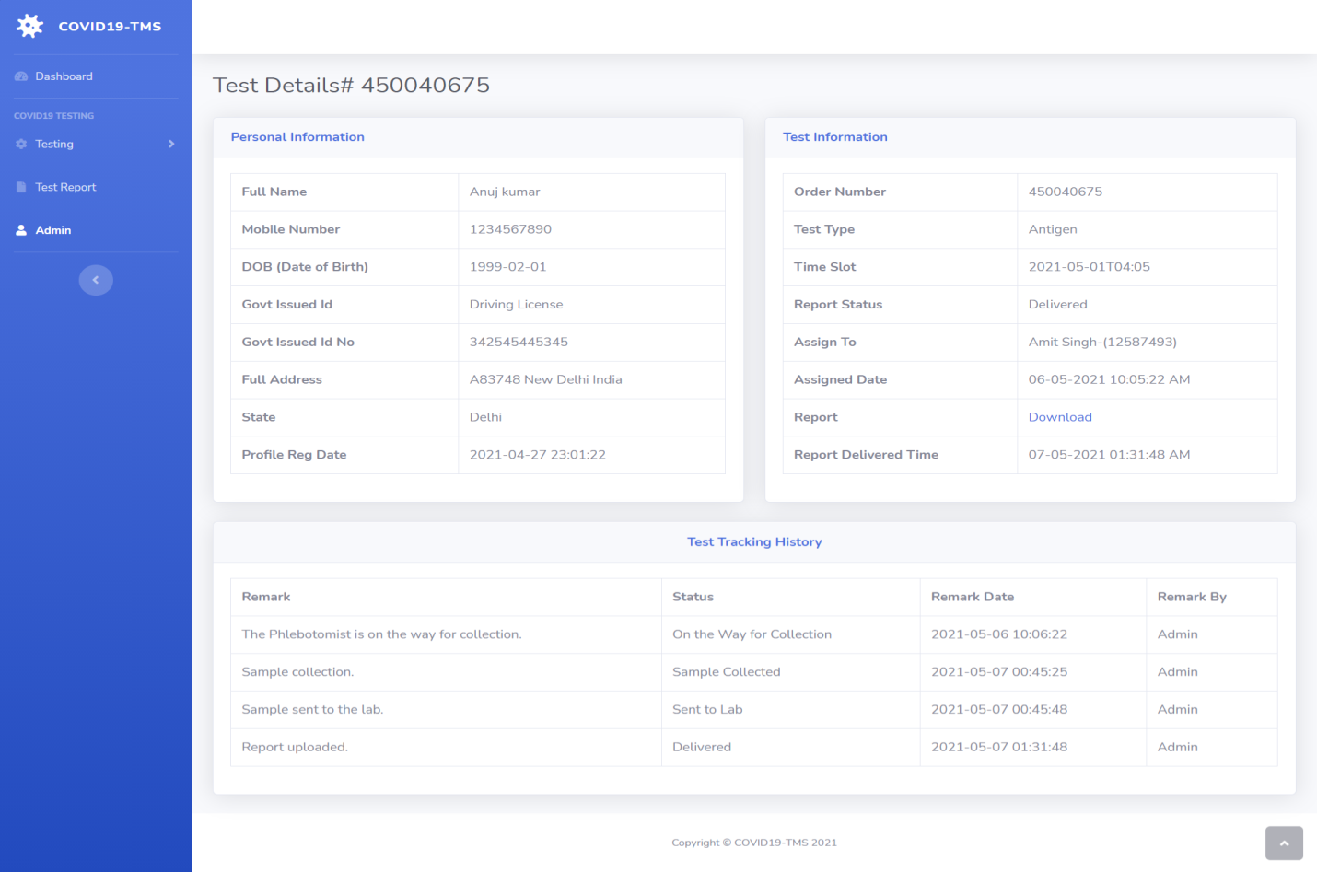

**State Wise Dashboard**

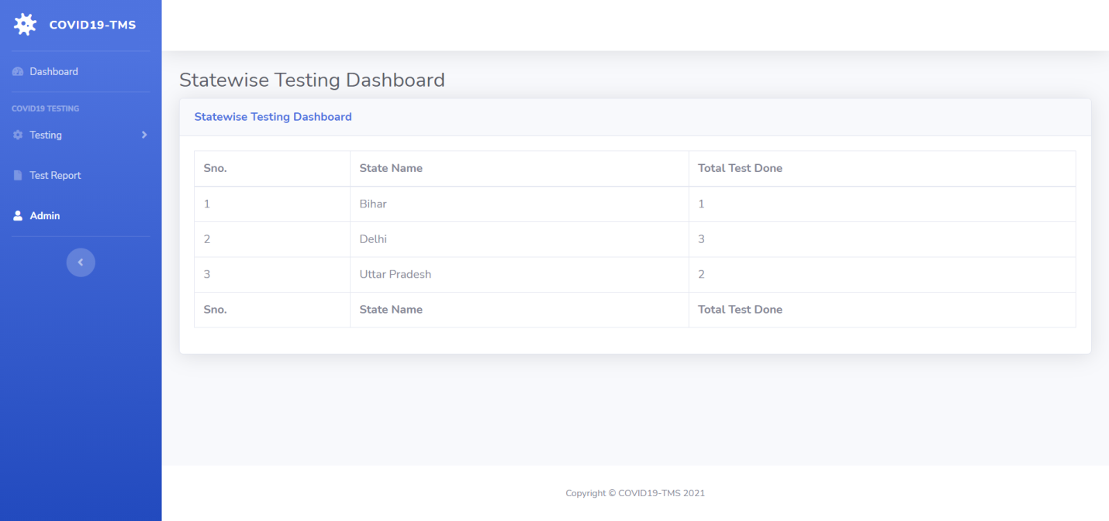

**Admin Login**

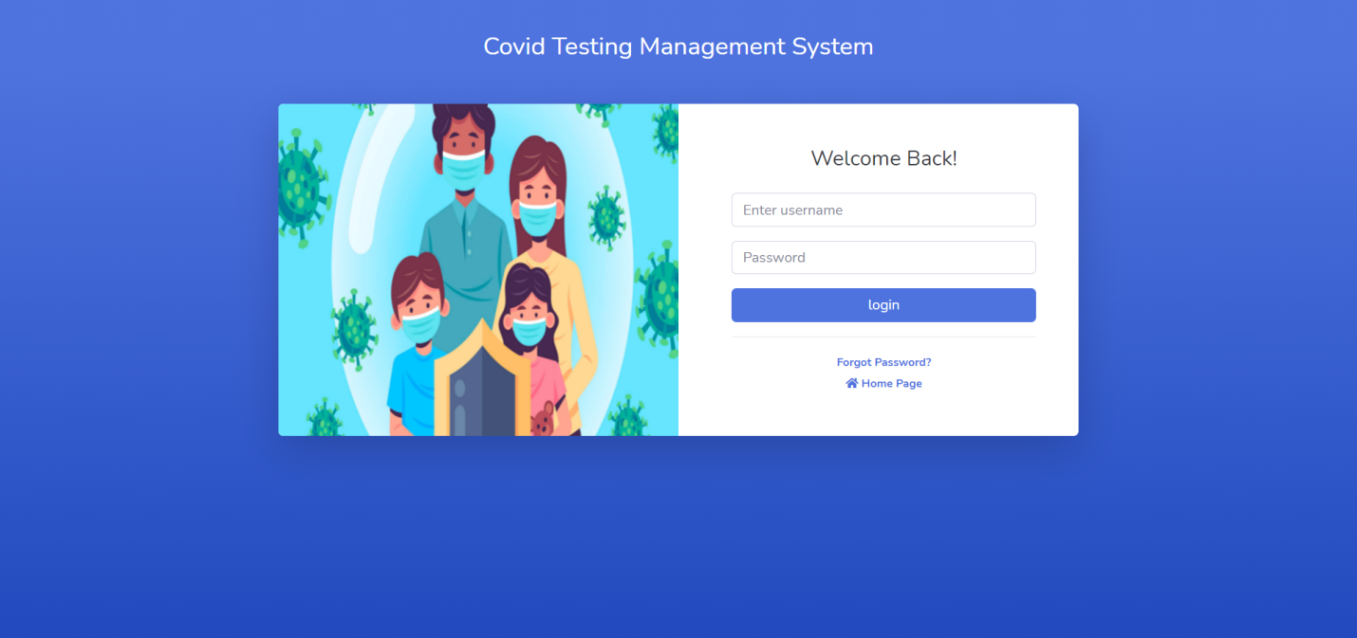

**Admin Password Recovery**

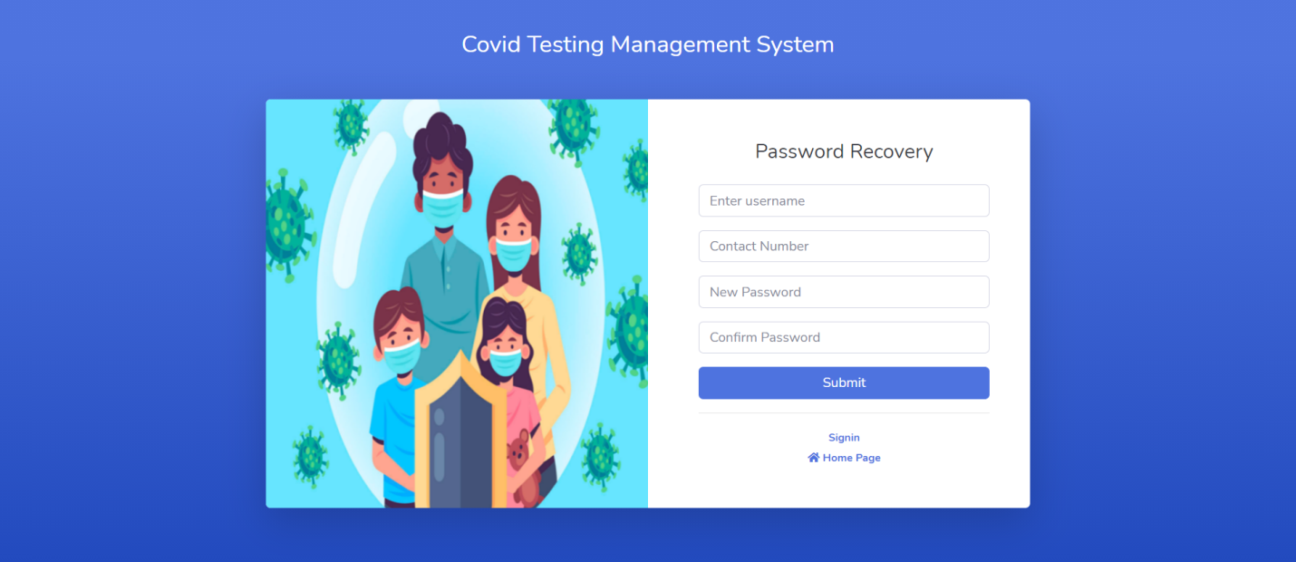

**Admin Dashboard**

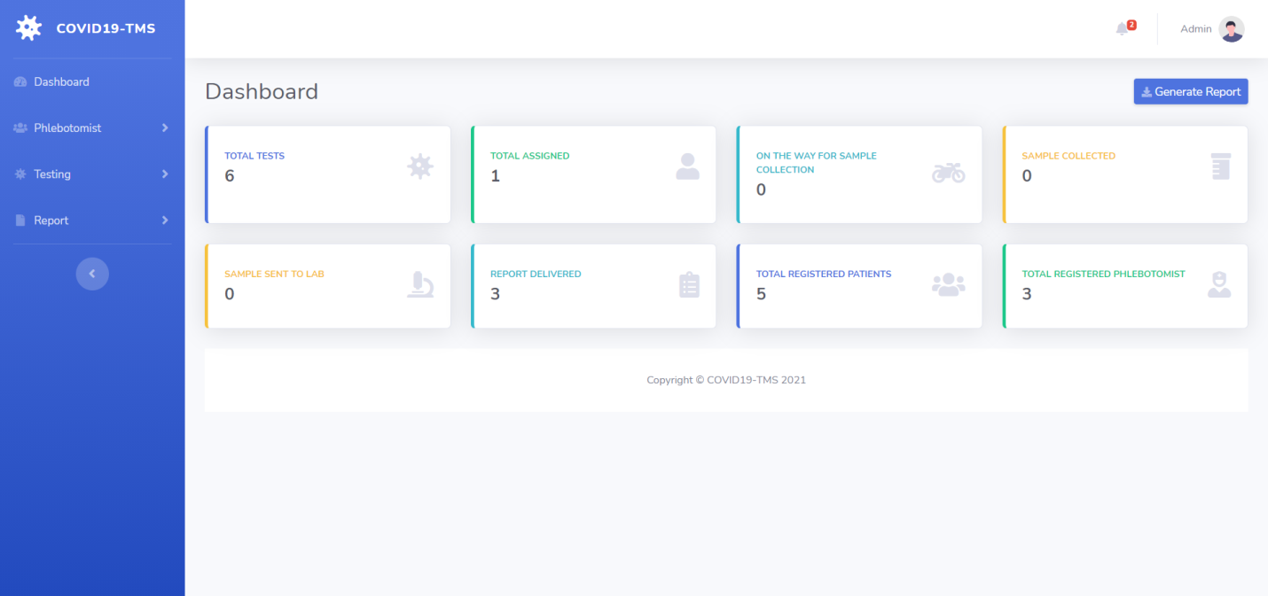

**Admin Notification**

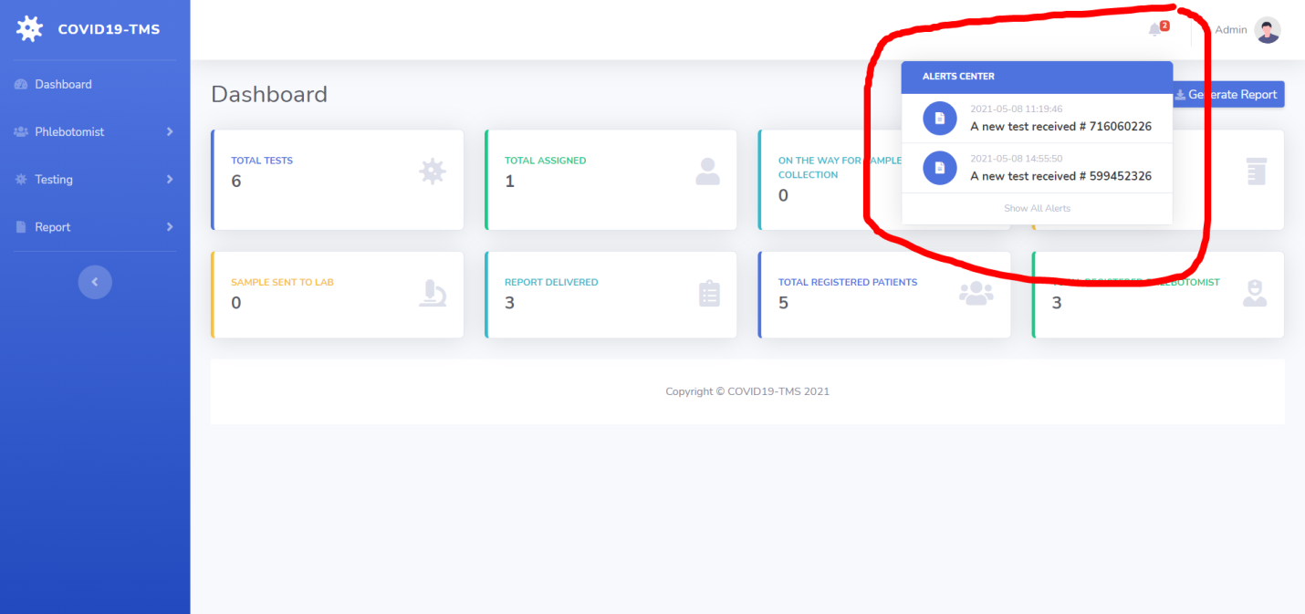

**Add Phlebotomist**

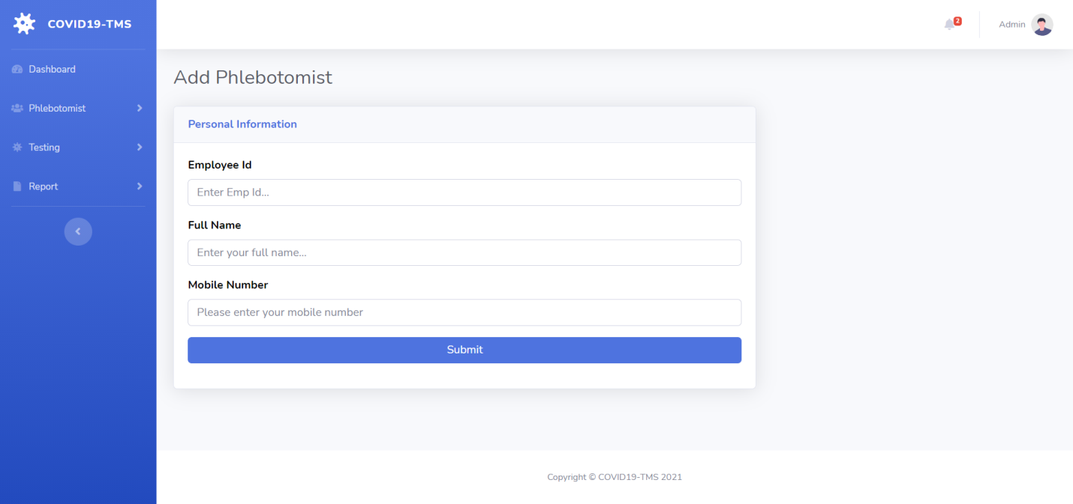

**Manage Phlebotomist**

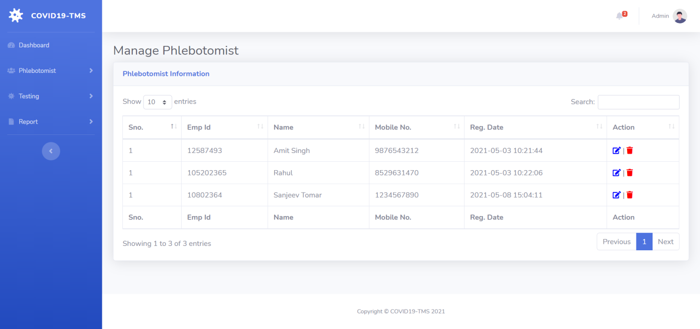

**Edit/Update Phlebotomist Information**

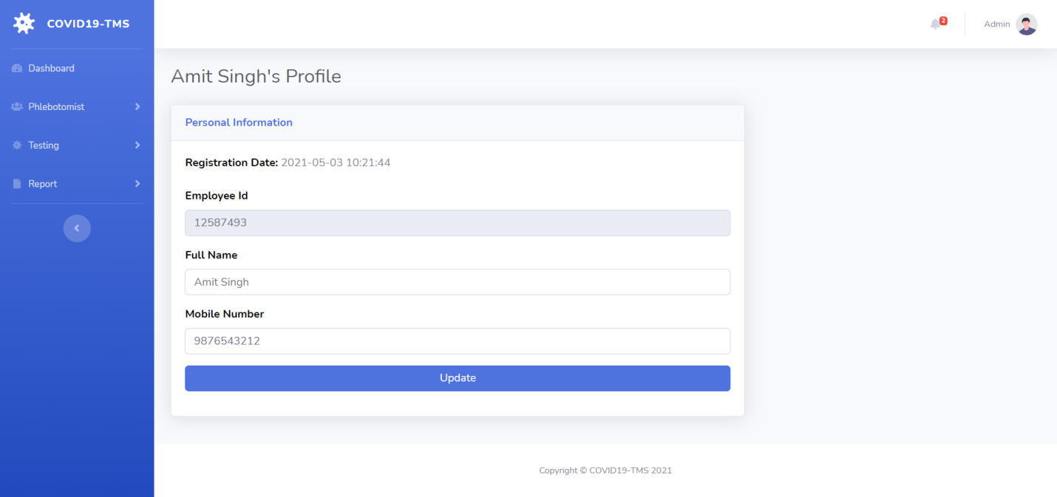

**New/Assigned/On the way for collection/Sample Collected /Sent to Lab / Delivered / All Tests**

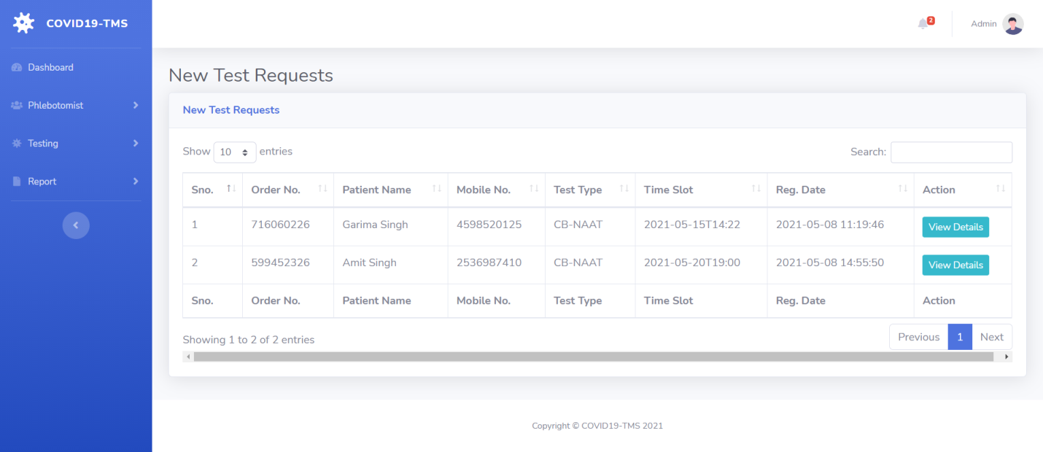

**Test Details-1**

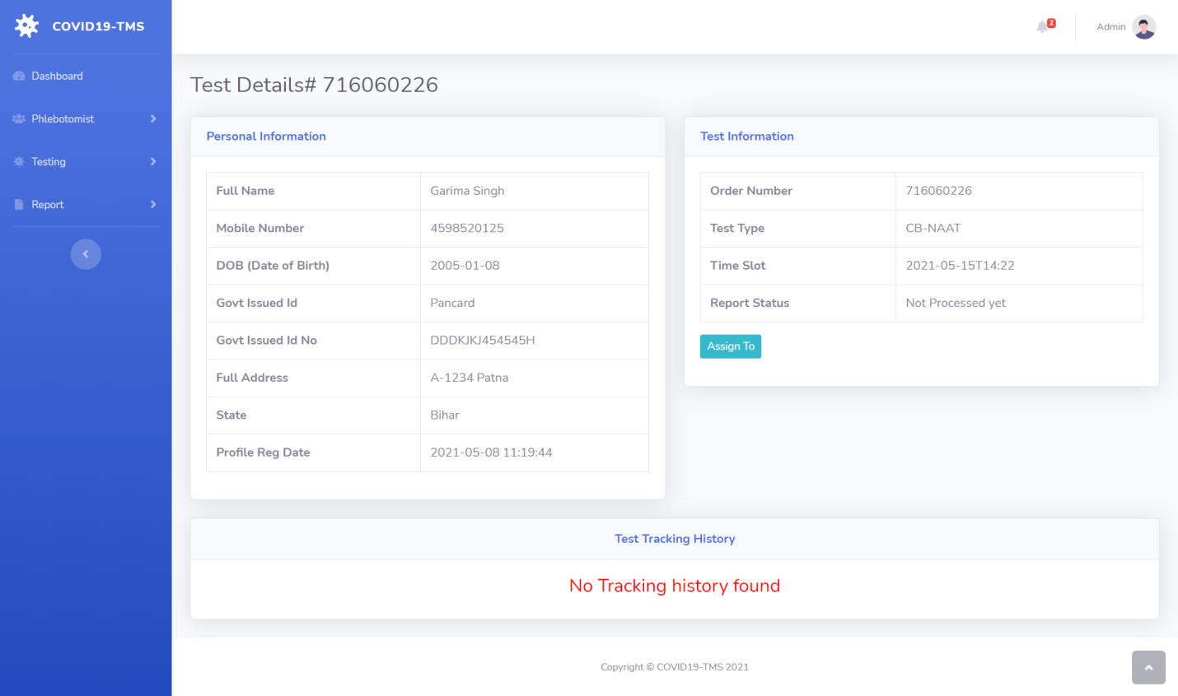

**Assigned to**

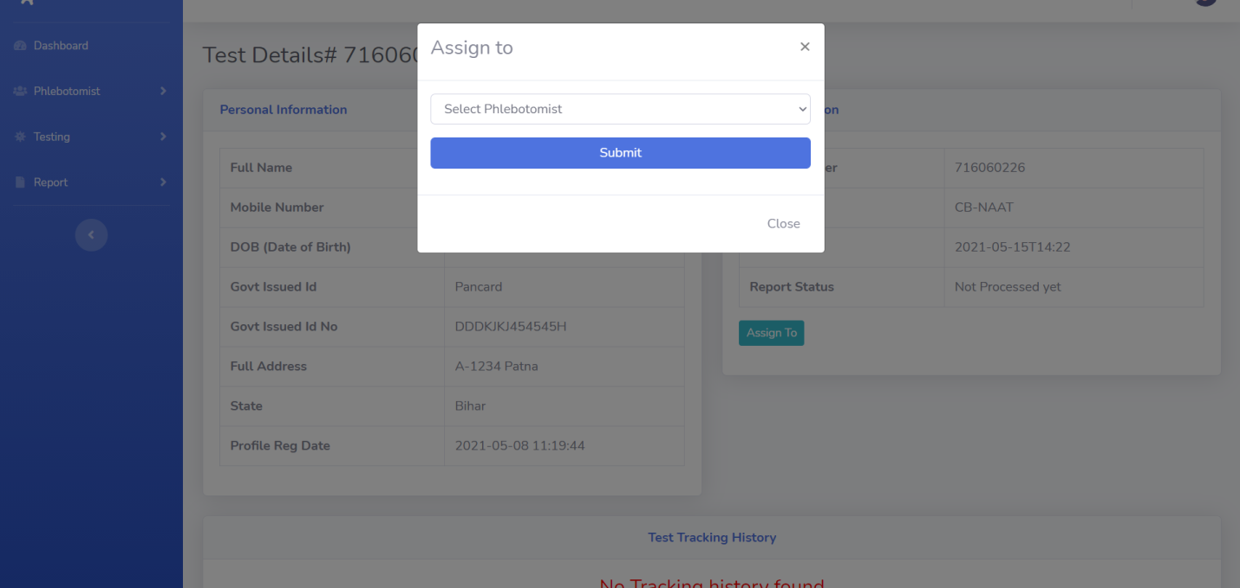

**Take Action**

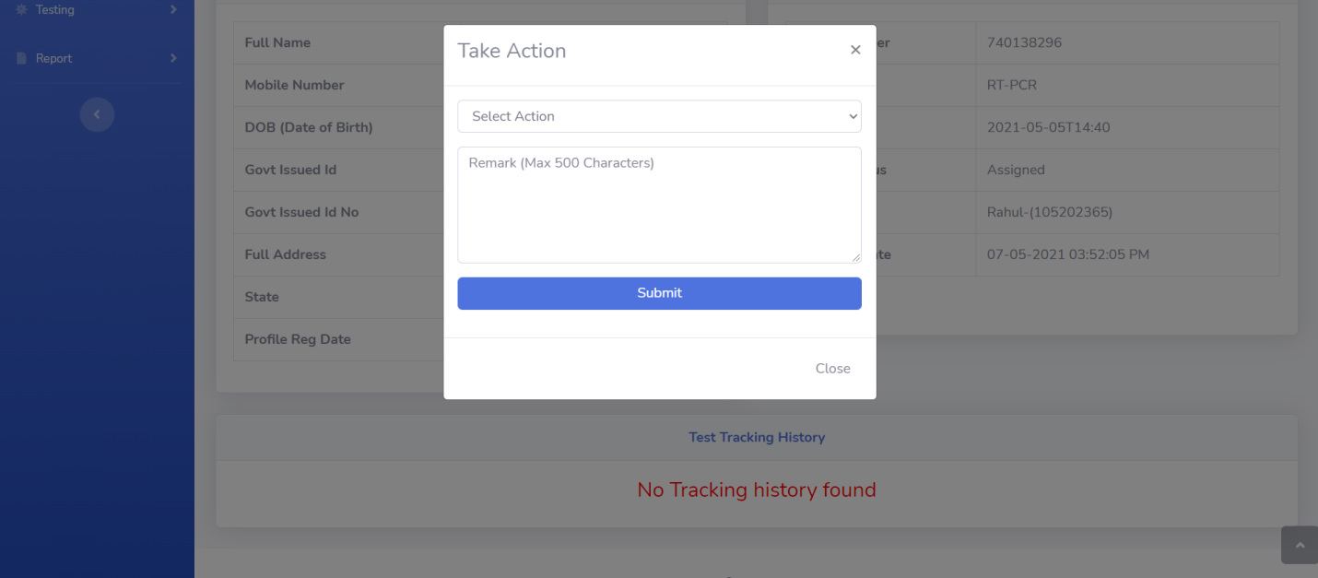

**Test Details Admin**

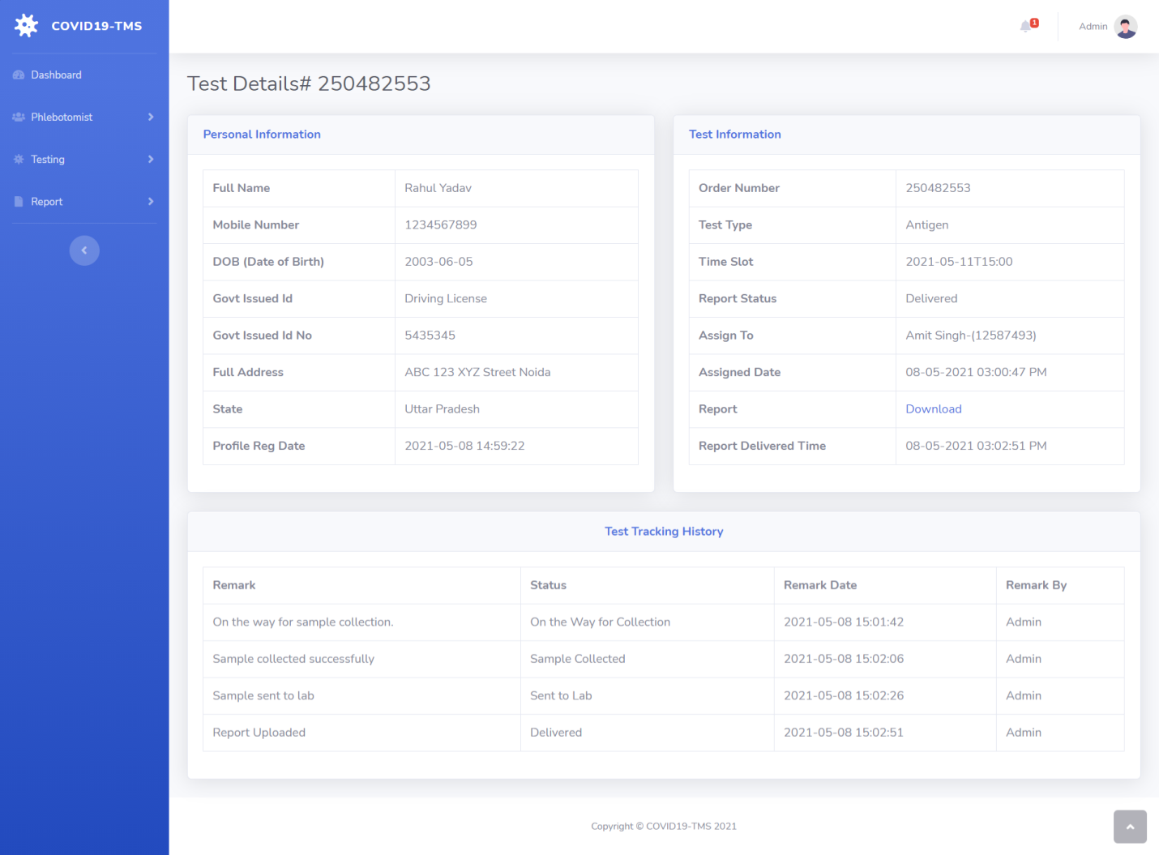

**Reports**

**B/w Dates Report Date Selection**

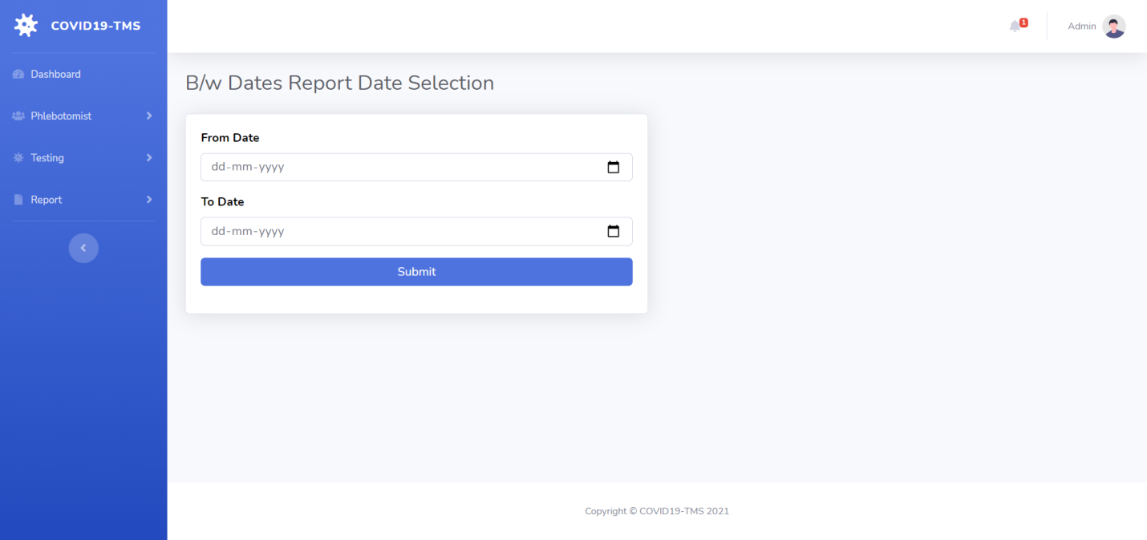

**B/w Dates Test Result**

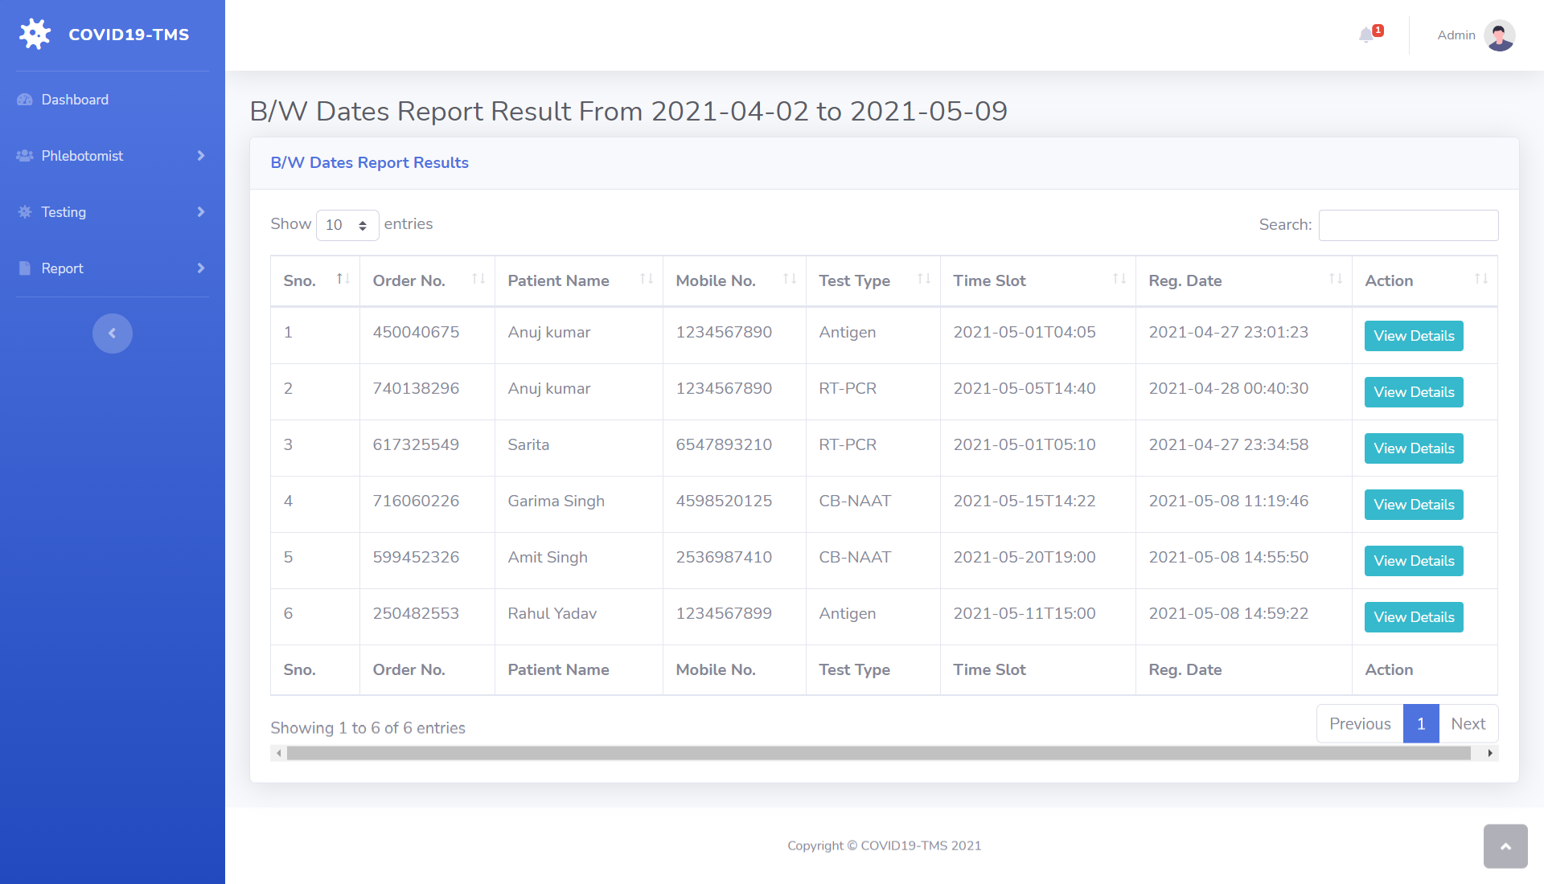

**Search Report**

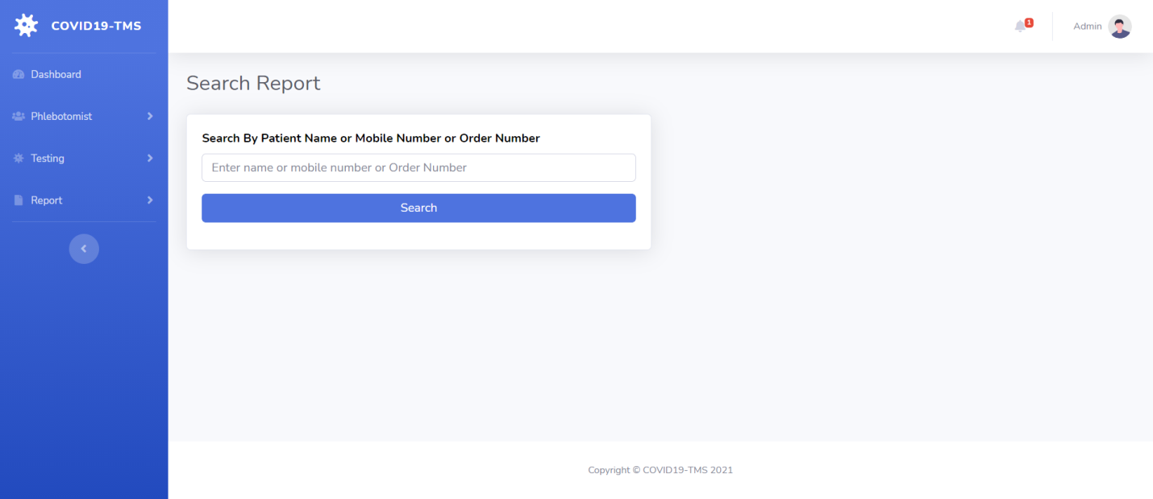

**Search Report Result**

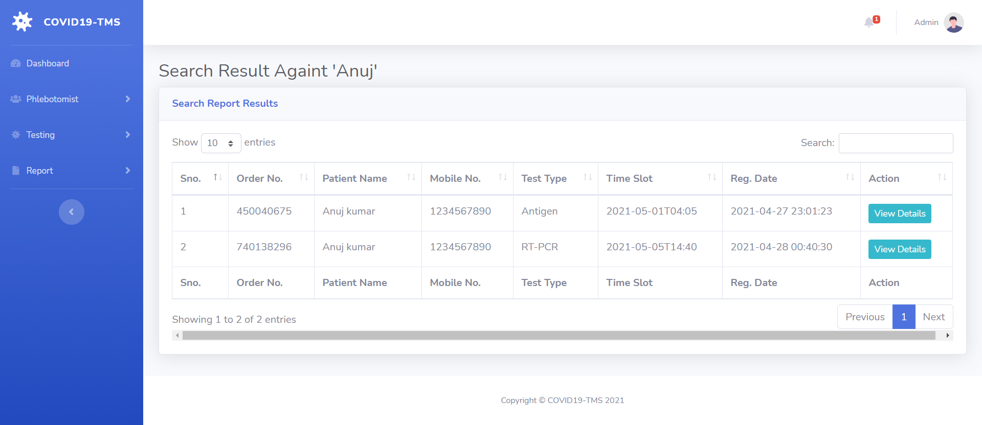

**Admin Profile**

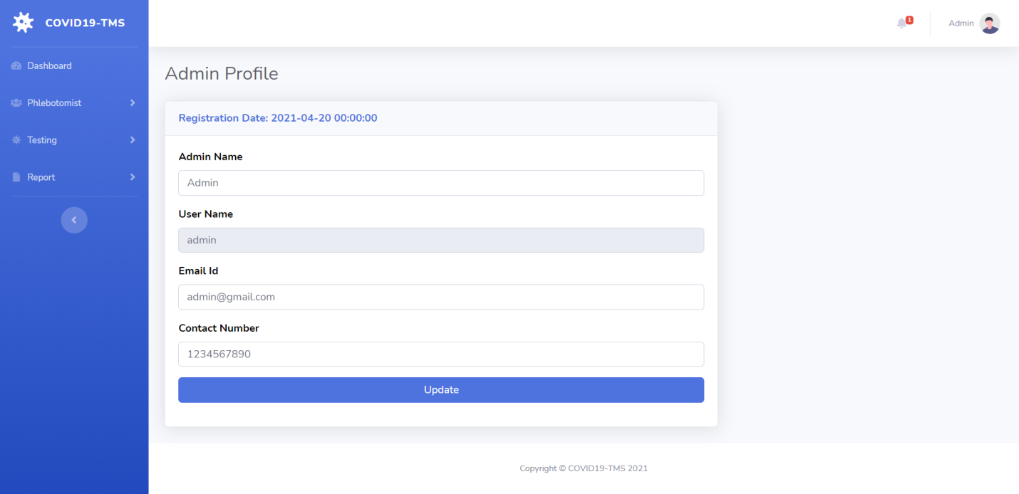

**Admin Change Password**

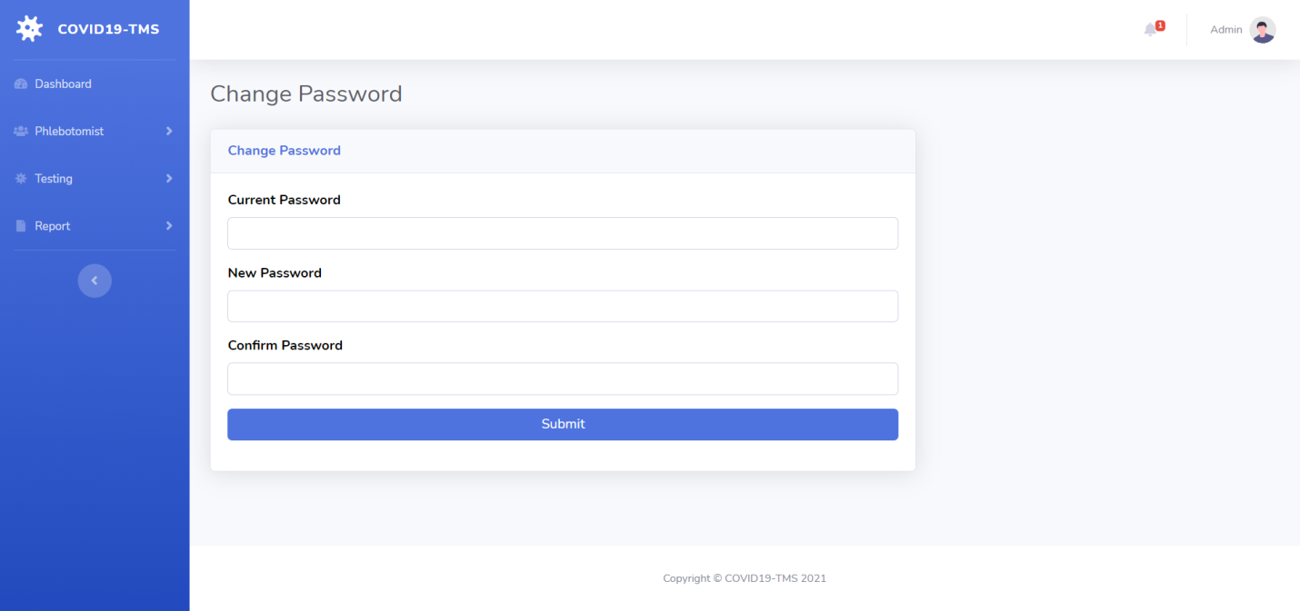

**Admin Logout**

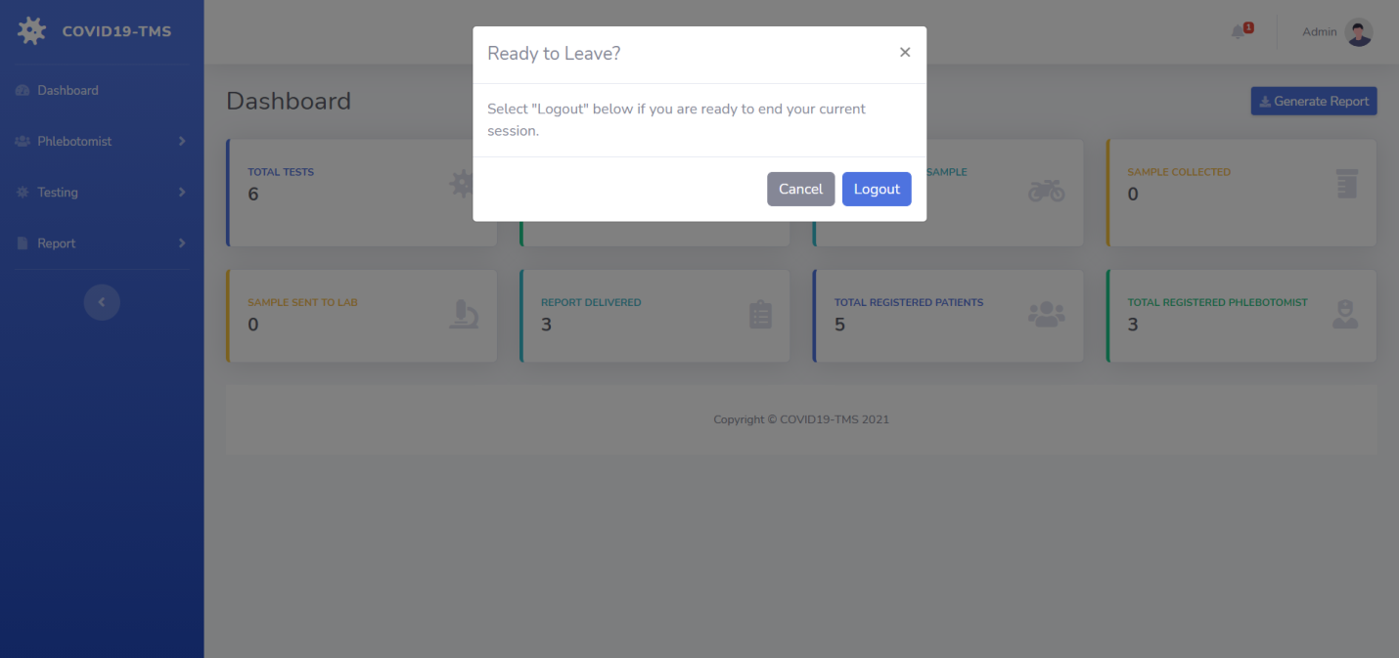

**Conclusion**

COVID19 Testing Management System is very much graceful and lively. Patients have to register to the portal by giving their details and then they can take appointment through online with minimal effort. The Phlebotomist comes to patient address to collect the sample. Once test is done and test report is generated patient can download the report by logged in to the portal. This system can be implemented in diagnostic labs and clinics.

* Automation of the entire system improves the productivity.
* It provides a friendly graphical user interface which proves to be better when compared to the existing system.
* It gives appropriate access to the authorized users depending on their permissions.
* It effectively overcomes the delay in communications.
* Updating of information becomes so easier.
* System security, data security and reliability are the striking features.
* The System has adequate scope for modification in future if it is necessary.

**References**

**For PHP**

* <https://www.w3schools.com/php/default.asp>
* <https://www.sitepoint.com/php/>
* <https://www.php.net/>

**For MySQL**

* <https://www.mysql.com/>
* [http://www.mysqltutorial.org](http://www.mysqltutorial.org/)

**For XAMPP**

* <https://www.apachefriends.org/download.html>